RKB Accounting & Tax Services  61-130 Bass Pro Mills Drive, Suite 203  Concord ON L4K 5X2  Call: 647-692-5677  Email: raj@rkbaccounting.ca  www.rkbaccounting.ca | 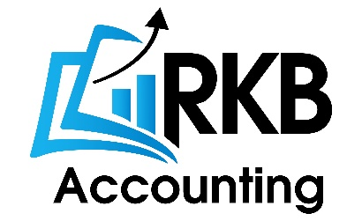

CLIENT INFORMATION – US TAX

Did you file US tax last year, please provide a copy and do not answer 1. To 14. unless there are changes:
- Name:
- Date of birth:
- SSN / ITIN Number:
- Spouse’s Name:
- Spouse’s Date of birth:
- Spouse’s SSN / ITIN Number:
- Address Canada:
- Address USA:
- Citizenship of country:
- Phone Canada:
- Phone USA:
- Did you ever apply for US Green Card or hold Green Card:
- Were you ever US citizen:
- Country of residence in the tax year:
- Dates - Entered and Exit from USA in last 3 Years, provide only for the tax year if you are providing your last filed US tax return:
- Did you have a driving license in USA:
- Did you have a bank account in USA:
- Scan me all your W slips:
- Scan me your properties purchase/closing documents:
- Scan me your business and rental statements with a copy of last month’s bank statement and bank reconciliation
- Scan me your donations in USA:

